FIRST ENERGY’S WOMEN IN LEADERSHIP

(WIL) 2020 VIRTUAL SIGNATURE EVENT

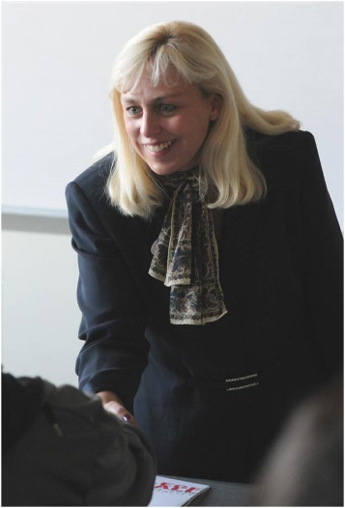
Hello! I am Michelle Coussens and will be facilitating your upcoming First Energy Women in Leadership (WIL) 2020 Virtual Signature Event coming up on October 22nd. I look forward to sharing my thoughts on how to manage today’s generational mix, ways to find and lead some work/life balance (particularly during these remote times), and some tools and techniques to advance your presentation skills and increase your influence. Because the topics selected by your steering committee are such important parts of leadership, I thought I would share a few points below from Brene Brown's book Dare to Lead that I found particularly relevant as I approached my preparation for our sessions. I encourage you to not only read her book but to watch her Netflix special The Call to Courage when you have time. It is both insightful and entertaining.
Brene describes a leader as "anyone who takes responsibility for finding the potential in people and processes, and who has the courage to develop that potential" (p.4). She describes ten behaviors that stand in our way when trying to lead, which I summarize as:
- Avoiding tough conversations, which just perpetuates issues
- Managing tasks but not people's thoughts and feelings about change
- Fostering distrust by not empathizing with others
- Avoiding calculated risk-taking
- Addressing symptoms rather than true underlying problems
- Blaming each other rather than holding ourselves and others accountable and learning from our mistakes
- Disengaging rather than confronting our own biases and having honest conversations about them
- Rushing to solutions rather than taking the time to find long-term or more advantageous options
- Deriving value statements but not spending enough time on "walking the talk" in our organizations; and
- Working in an environment of perfectionism and fear that keeps people from volunteering new ideas and personal growth.

Before the event, I recommend that you download and print the slides for each session, as well as the accompanying participant workbook. You will gain more value if you actively participate in the discussions, and the workbook provides associated exercises we will be working through, as well as spaces for reflection during the sessions. If you have any questions, please feel free to reach out to me. I look forward to working with all of you!

